Leasing Information

Executive Suite
Office Space
Available Now
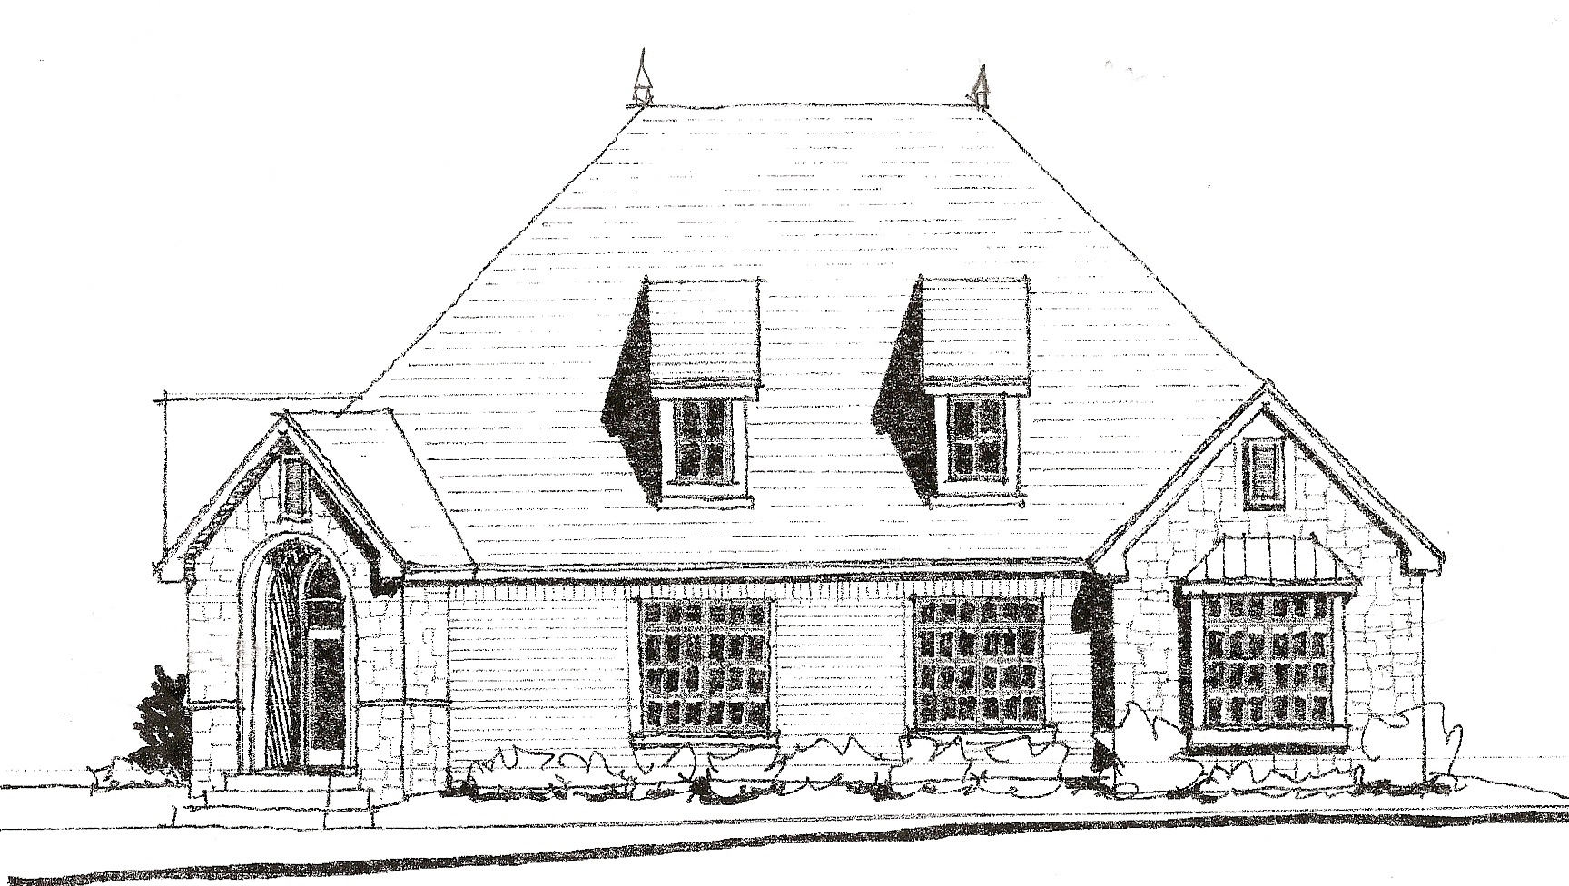

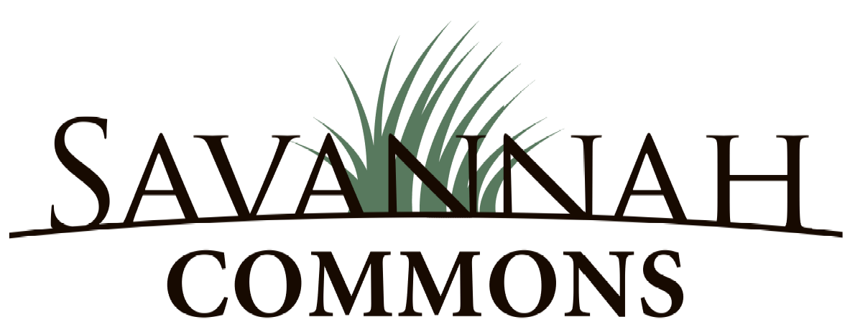

P.O. Box 250  Mustang, OK 73064  (405) 376-3704  (405) 376-3722 Fax
www.CroutCompanies.com

1448
Office Building

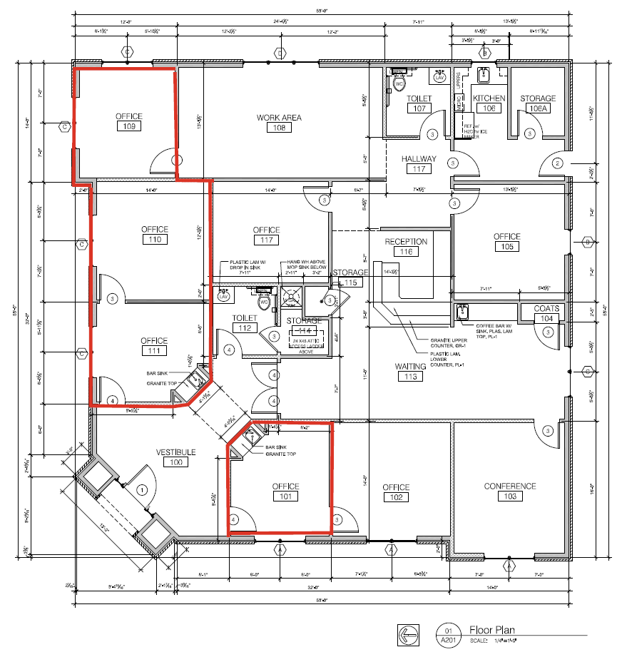
- Tenant Buildout Available
- 4 Offices, Reception Area, Kitchen, Waiting Room, Restrooms, Storage
- Residential Style Office Buildings
- Maintained Office Village With Upscale Landscaping
- Quiet Environment
- Utilities Included (Electric, Gas, Water and Sewer)
- Elegantly Decorated Common Entry
- Granite Coffee Bar With Sink in Each Space
- Common Tenant Restroom
Call Now For Leasing Information
376-3704

